**UDP Interface Specification – 2-Axis Gantry Control**

# Overview

This document defines a UDP-based protocol for controlling and monitoring a 2-axis gantry. Communication is performed over a broadcast-capable Ethernet network using designated UDP ports on both ends.

# Network Configuration

Gantry (PLC) IP Address: 192.168.4.201

Subnet Mask: /16 (255.255.0.0)

Broadcast Address: 192.168.255.255

Protocol: UDP

PLC UDP Port: 3001 (receives setpoints, sends status)

PC UDP Port: 3000 (sends setpoints, receives status)

Broadcast: Enabled

# Functional Description

The unit of all position and velocity/acceleration values are mm and respectively mm/s and mm/s².

If a new position is sent, the current movement is aborted and the new movement is directly started, assuring the best possible reaction time.

Errors should always be automatically acknowledged. If this is not the case, the acknowledge-bit of the setpoint data structure can be used.

# Data Structure

## Setpoint Values (sent from PC to PLC at port 3001)

| **Field** | **Type** | **Size (Bytes)** | **Description** |
| --- | --- | --- | --- |
| enable | boolean | 1 | Enables/Disables gantry motion via a rising/falling edge |
| acknowledge | boolean | 1 | Acknowledges and resets errors via a rising edge |
| (padding) | uint8[6] | 6 | Padding for 8-byte alignment |
| velocity | double | 8 | Desired velocity (0 for maximum velocity) |
| acceleration | double | 8 | Desired acceleration (0 for maximum acceleration) |
| x | double | 8 | Target X position |
| y | double | 8 | Target Y position |

**Total Size**: 1 + 1 + 6 + 8 + 8 + 8 + 8 = **40 bytes**

Note: Padding ensures proper 8-byte alignment for doubles.

## ActualValues (broadcast from PLC to PC at port 3000)

| **Field** | **Type** | **Size (Bytes)** | **Description** |
| --- | --- | --- | --- |
| ready | boolean | 1 | System ready |
| enabled | boolean | 1 | System enabled |
| error | boolean | 1 | Error present |
| (padding) | uint8[5] | 5 | Padding for 8-byte alignment |
| velocity | double | 8 | Current velocity |
| x | double | 8 | Current X position |
| y | double | 8 | Current Y position |

**Total Size**: 1 + 1 + 1 + 5 + 8 + 8 + 8 = **32 bytes**

# Data Encoding

Endianness: Little-endian

Boolean values: 1 byte (0x00 = false, 0x01 = true)

Numeric values: IEEE 754 64-bit doubles

Alignment: All doubles are 8-byte aligned. Padding is added as needed.

# Communication Pattern

PC → PLC (SetpointValues, unicast or broadcast to port 3001)

PLC → PC (ActualValues, periodic UDP broadcast to port 3000)

# Error Handling

If error is true in ActualValues, the gantry awaits acknowledge = true in SetpointValues to reset.

Motion commands are ignored during an error state until reset.

# Additional information

The PLC has a web UI that is available via

<http://192.168.4.201:8080/webvisu.htm>

In the UDP tab, the currently sent and received data can be analyzed for debugging purposes.

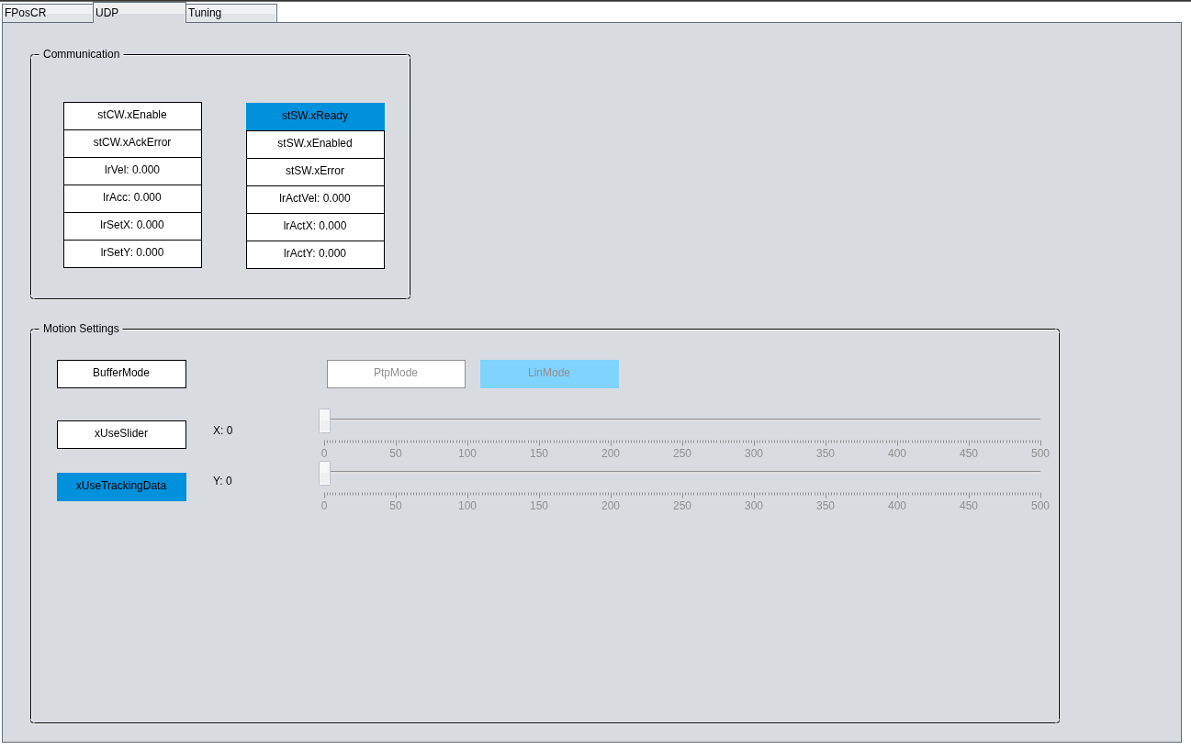

Diagnosis tab for the UDP communication

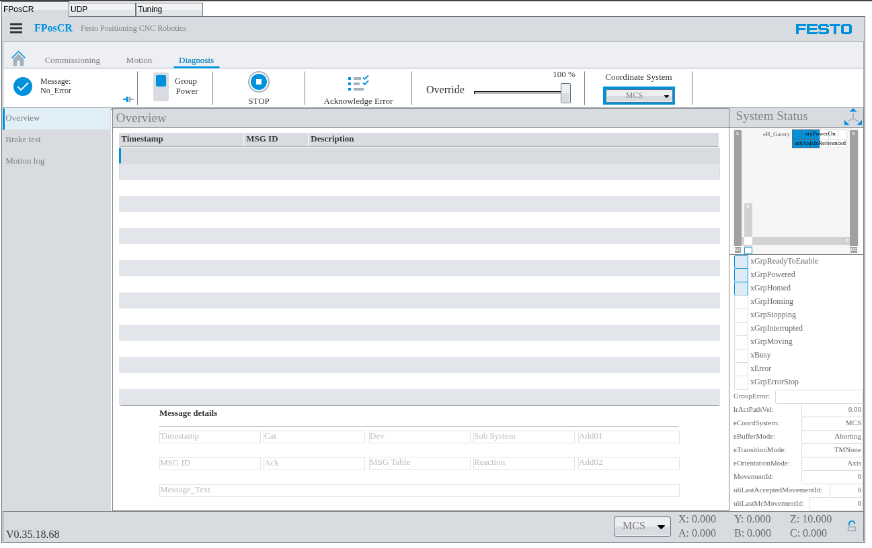

Diagnosis tab for motion errors